Data Validation :

Check for Duplicates :

* Fact Table :

SELECT order_id, COUNT(1)

FROM public.fact_orders

GROUP BY 1

HAVING COUNT(1) > 1 ;

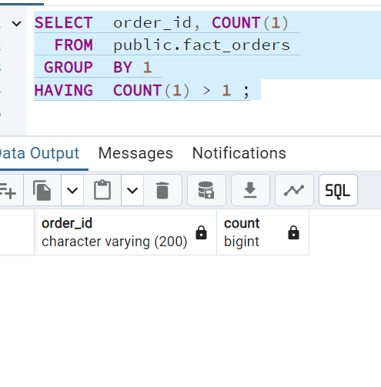

Dimension Tables :

**Dim_customers** :

SELECT customer_id,

COUNT(1)

FROM public.dim_customers

GROUP BY 1

HAVING COUNT(1) > 1 ;

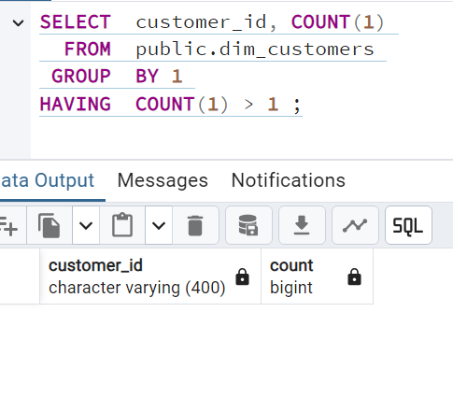

**public.dim_delivery :**

SELECT delivery_id,

COUNT(1)

FROM public.dim_delivery

GROUP BY 1

HAVING COUNT(1) > 1 ;

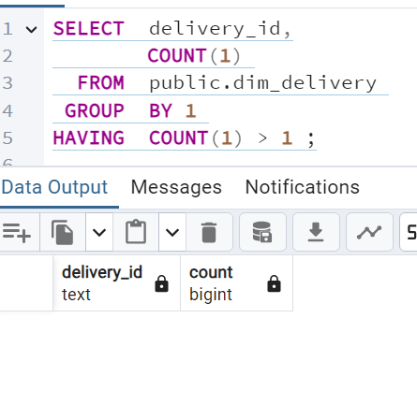

Null Checks :

**Fact** :

SELECT *

FROM public.fact_orders

WHERE order_id IS NULL ;

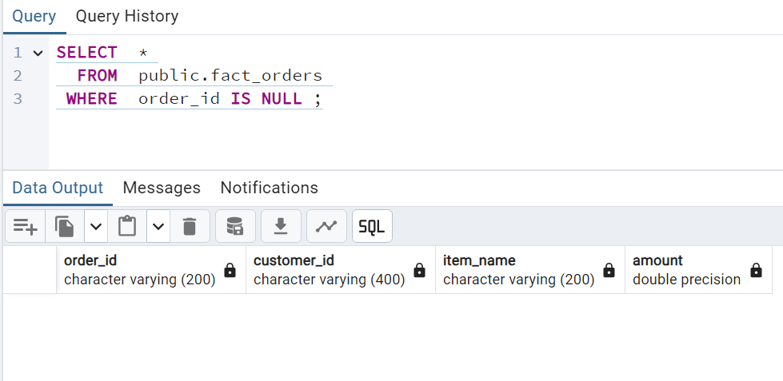

Dimensions :

Dim_customers :

SELECT *

FROM public.dim_customers

WHERE customer_id IS NULL ;

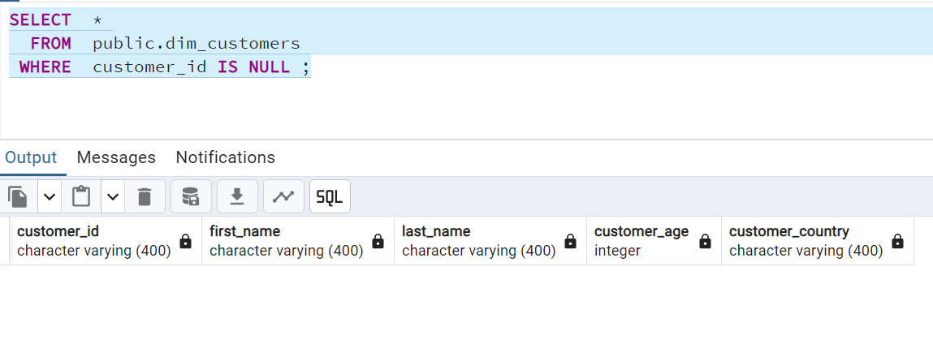

Dim_delivery :

SELECT *

FROM public.dim_delivery

WHERE delivrey_id IS NULL ;

